**Aryaman Mishra**

**19BCE1027**

LAB 8-CA CERTIFICATE IN BURP SUITE

Launch Burp suite from command line.

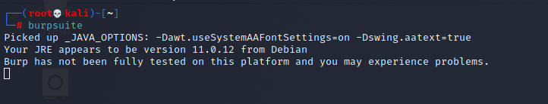

Select temporary Project and choose Burp default settings..

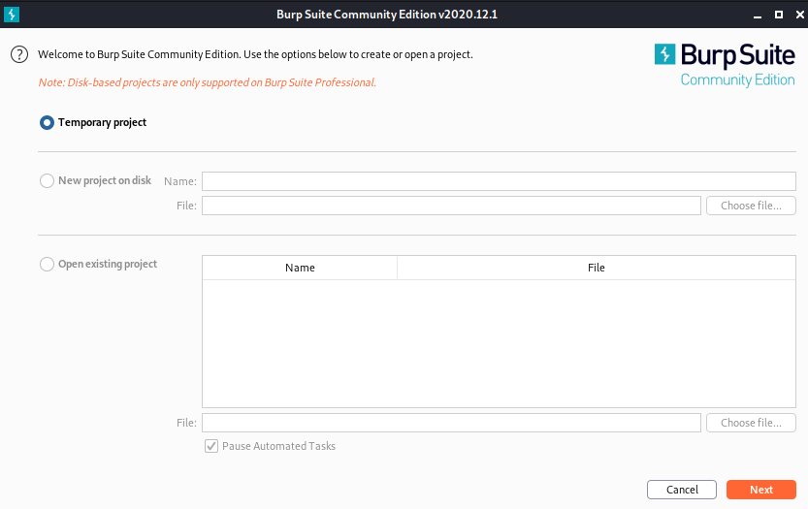

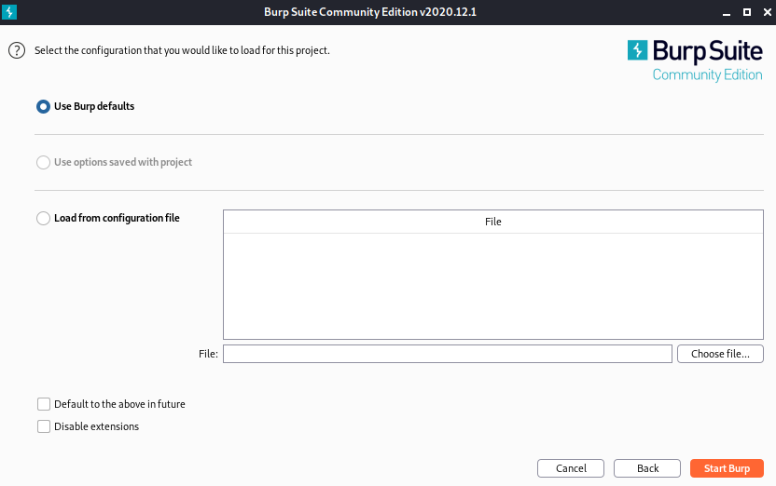

Go to Proxy tab and then to options.

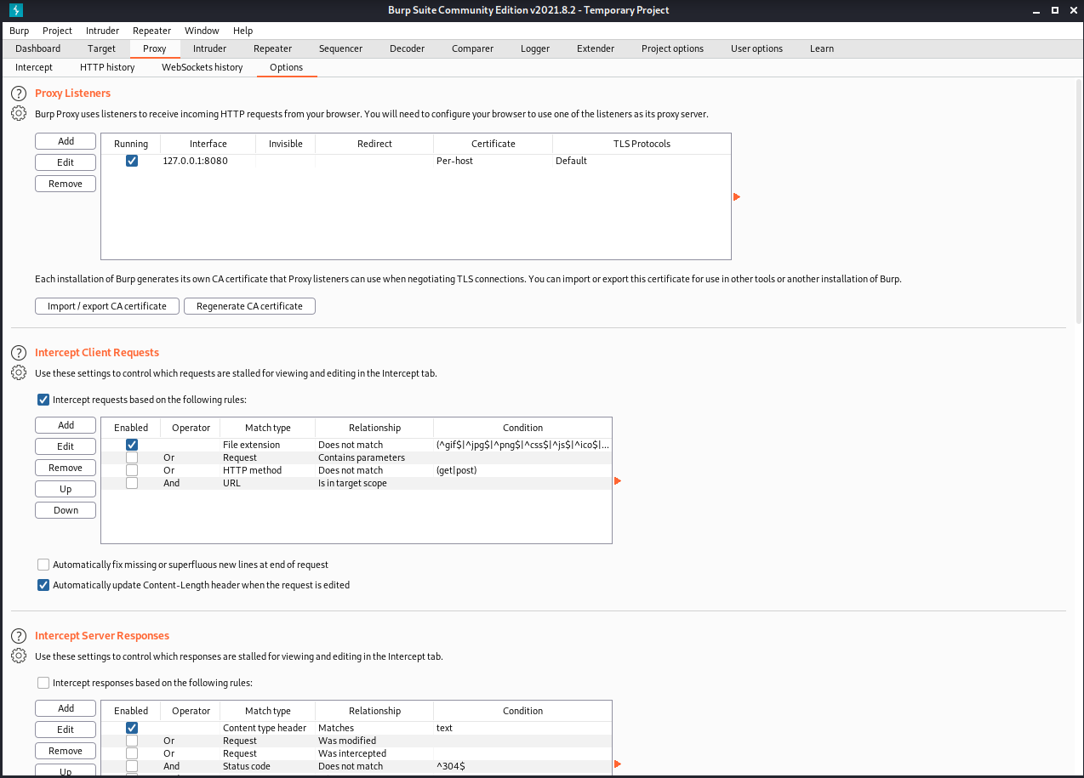

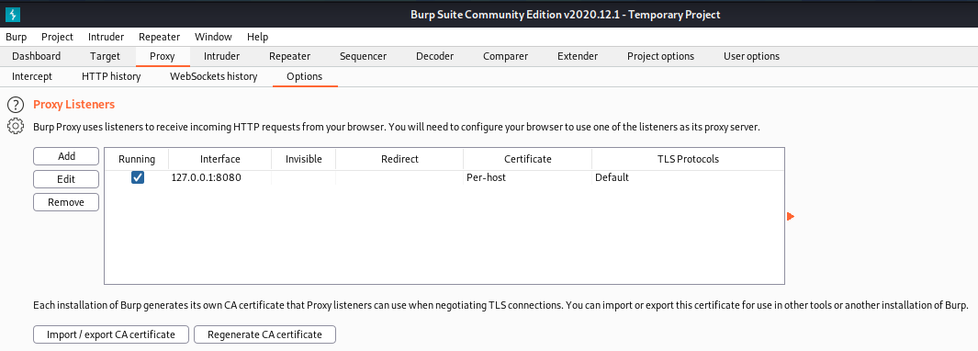

Burp is listening on this port and this interface.

The socket is 127.0.0.1:8080(loopback interface).Any request on this specific loopback interface will be captured by Burp.

We cannot send any request on the loopback interface so we will open Firefox browser.

Now Burp is ready to see requests from the browser.

To redirect requests on the proxy and not server,we will have to configure our Browser.

Mention target IP address on Manual settings.

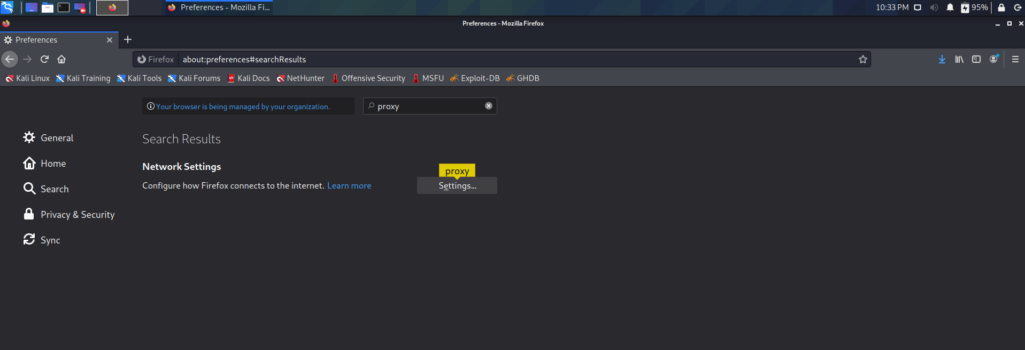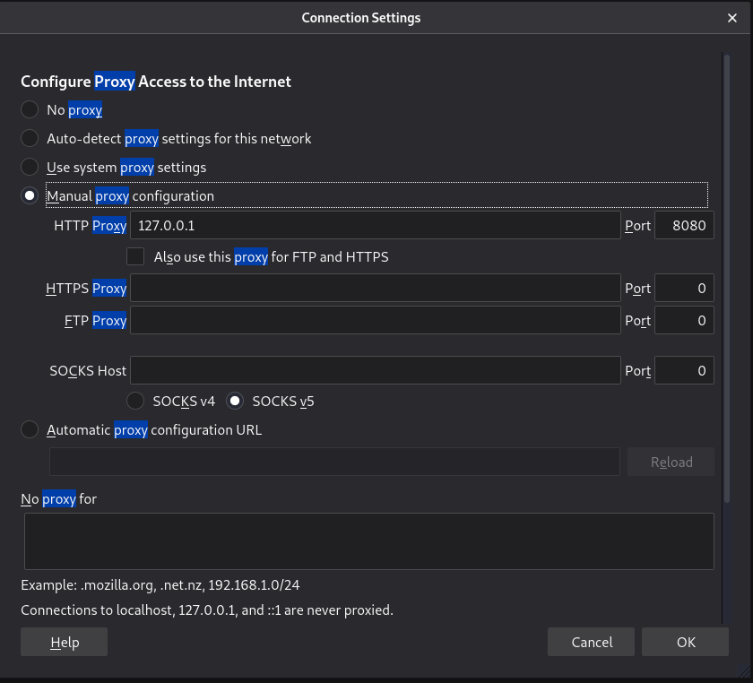

Any request will go through our Proxy.

Select Manual proxy option and type proxy ip same as that on burpsuite i.e. 127.0.0.1:8080.

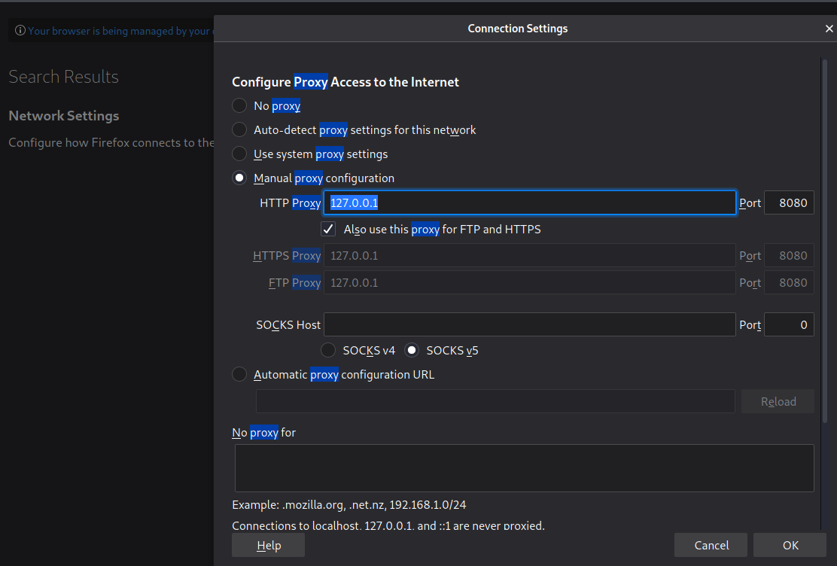

Now we will try to open a demo test website at **http://demo.testfire.net.**

Test site not loading when intercept is on for proxy as request reaches the proxy.



Intercept is highlighted orange.

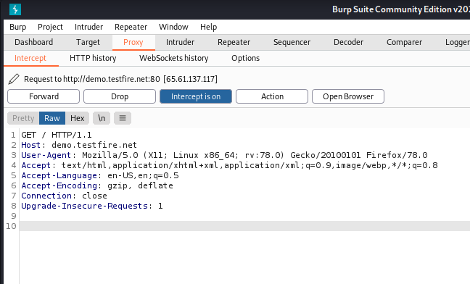

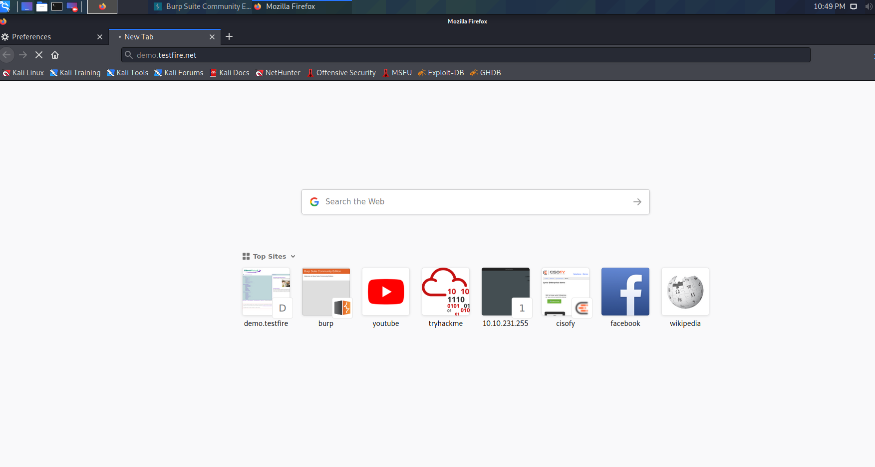

When intercept is off it will allow them to pass through.

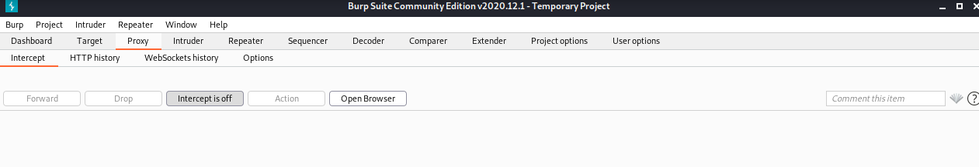

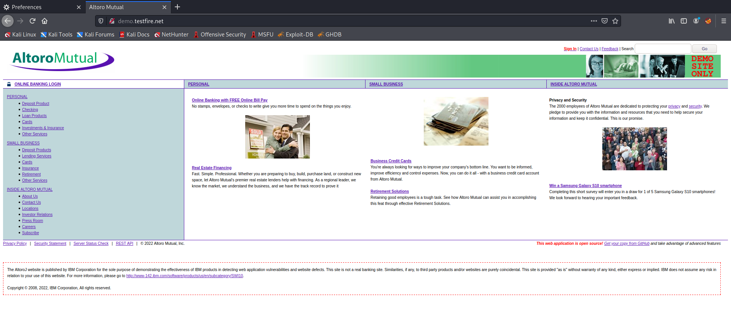

Download some CA certificates for burp in our browser so that the sites run.

Download certificate

Go to site <http://burp>

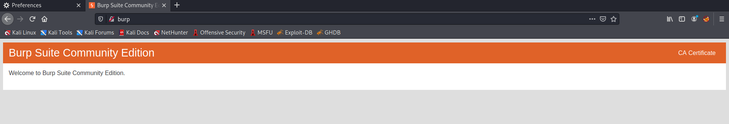

Click on CA certificate

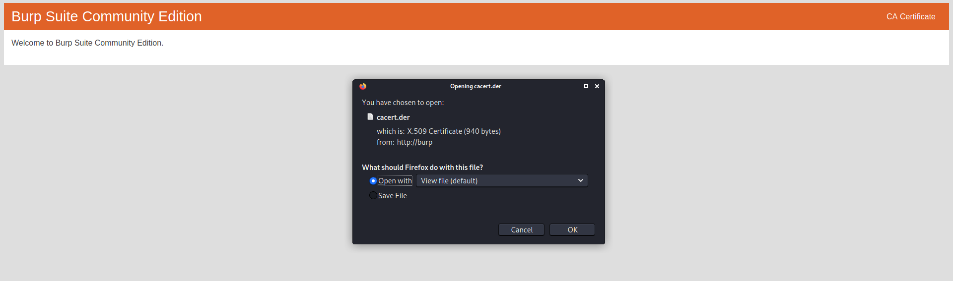

Download the certificate.

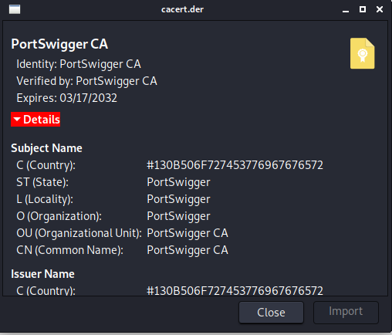

Import the certificates.

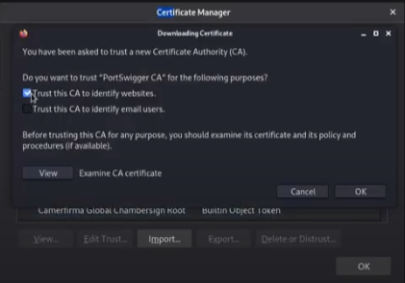

Download FoxyProxy add-on in Firefox.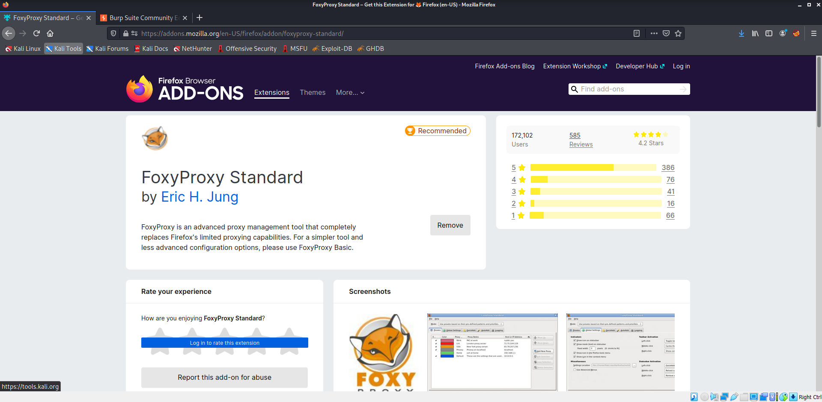

Click on options.

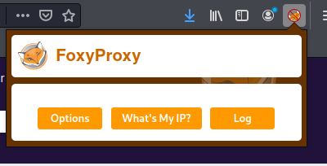

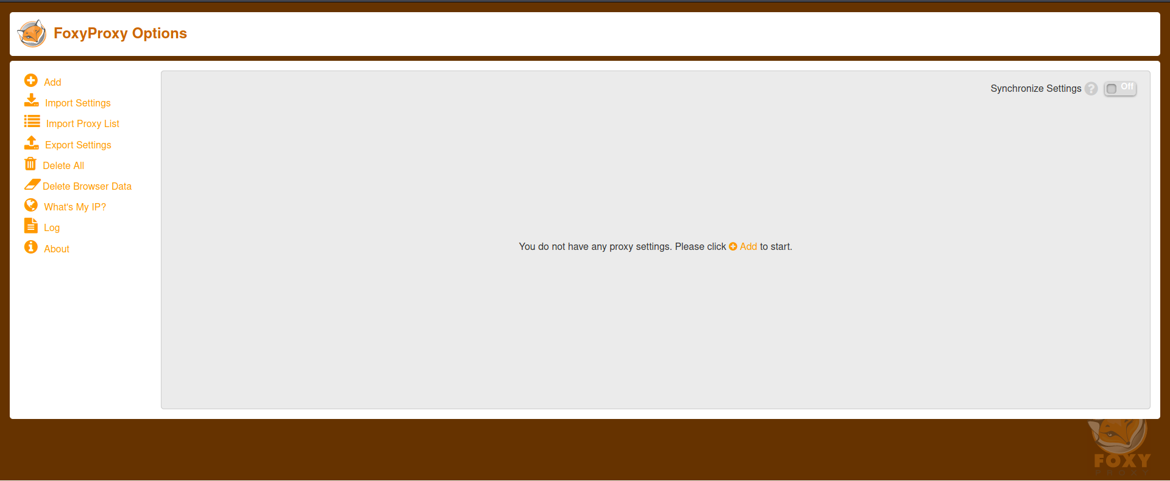

Fill proxy details and hit ‘save.’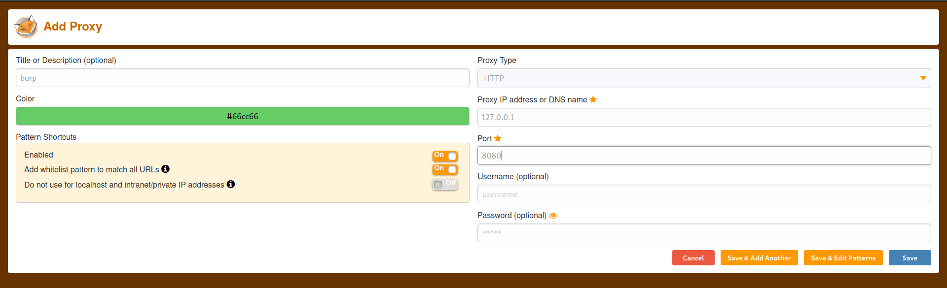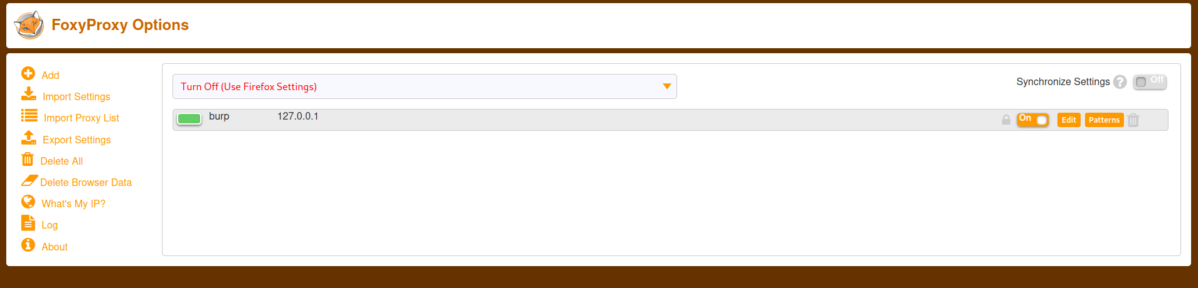

Revert to default settings in browser preferences.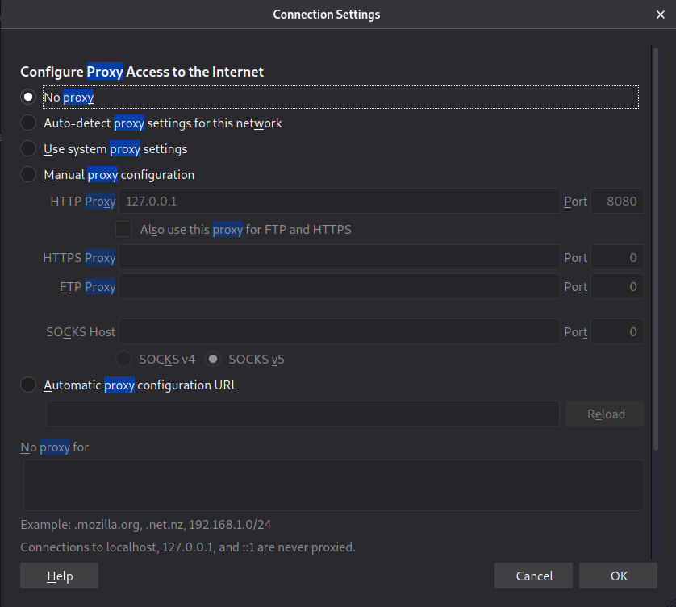

Enable burp proxy option in plugin.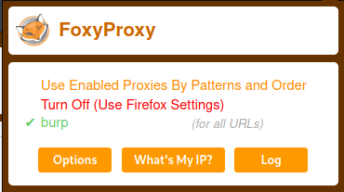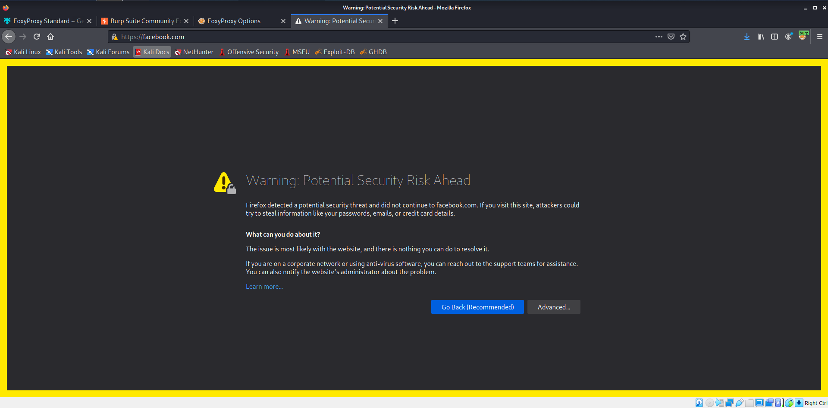 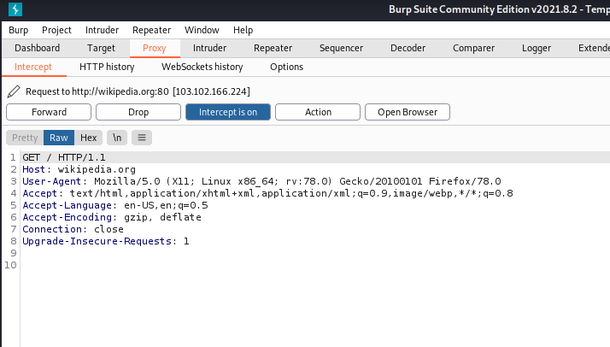

All requests will go through Proxy by Foxyproxy and not browser settings now.

**Conclusion:Burp suite and Proxy settings have been successfully implemented with their respective operations.**